|  |  |
| --- | --- |
| **Producto** | **Precio** |
| Barriga | **$71** |
| Cabeza | **$95** |
| Canal | **$45** |
| Capote | **$60** |
| Chamorro | **$33** |
| C. Lomo | **$68** |
| Costilla | **$62** |
| Cuero | **$29** |
| Cuero con Barriga | **$43** |
| Entrecot | **$58** |
| Espaldilla | **$57** |
| Espinazo | **$55** |
| Huacal | **$59** |
| Lomo | **$62** |
| Papada | **$35** |
| Pata | **$30** |
| Pierna | **$62** |
| Rabo | **$30** |
| Varilla | **$50** |

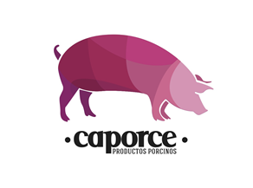

Precios de la semana del 24 al 29 de julio del 2017 (Los precios cambian dependiendo la fluctuación del puerco)